**Ideation Phase**

**Define the Problem Statements**

|  |  |
| --- | --- |
| Date | 19 September 2022 |
| Team ID | PNT2022TMID11377 |
| Project Name | Smart Farmer - IoT Enabled Smart Farming Application |
| Maximum Marks | 2 Marks |

**Problem Statement:**

In earlier days farmers used to calculate the readiness of soil and impacts doubts that created to sort the yield but they did not consider the level of water, particular atmospheric condition and identification of any humans or animals etc., through out their land unwantedly in un prescribed time.

In spite of growing industrialization and urbanization within the world, nearly one-half working population are still engaged in agriculture. In developing countries agriculture sector has been a major source of employment and it’s contributed to the economy. The fundamental aim of agriculture is to lift stronger and more fruitful crops and plants and to help them for their growth by improving the soil and supplying the water.

The agriculture activities in the world are closely controlled by physical factors.

Smart Agriculture can forecast weather data, switching ON the pump motor acknowledging the dampness of soil terms of moisture levels with help of soil moisture sensor which are interfaced to process module Arduino-UNO.

Fencing is done throughout the farm. For obstacles detection in the field at unnecessary times ultrasonic sensors can be used to detect the presence of objects throughout the time mentioned. The smart agriculture system can be operated from anywhere with help of networking technology.

Smoke sensors are used to detect smoke by sensing small particles in the air. After detection they give signals in the form of alarm sound. Smoke sensors are also used in warehouse for safety measures. To collect all the quantity from the warehouse if the expiry date is nearer, it must be intimated to the farmer

To interface all the hardware components to the application and the inputs should be received from the sensors and output must be displayed in web/application.

Reference: [Customer Problem Statement Template, Online Whiteboard for Visual Collaboration (miro.com)](https://miro.com/app/board/uXjVPR6CsUs=/)

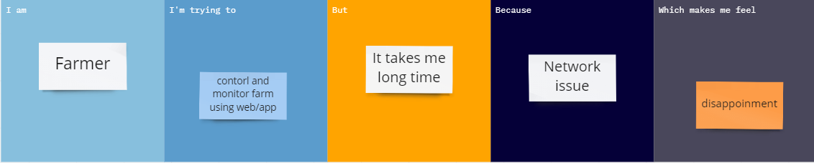

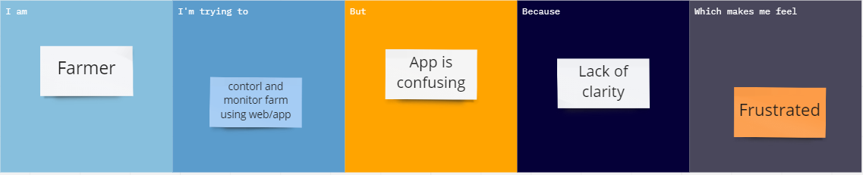

|  |  |  |  |  |  |
| --- | --- | --- | --- | --- | --- |
| **Problem Statement (PS)** | **I am (Customer)** | **I’m trying to** | **But** | **Because** | **Which makes me feel** |
| PS-1 | Farmer | Control and monitor farm using web/app | It takes me long time | Network issue | Disappointment |
| PS-2 | Farmer | Control and monitor farm using web/app | App is confusing | Lack of clarity | Frustrated |